Streaming MOVIE files in Opensim

Apple’s MOV files can be used to make region and parcel-wide video players. The Video you see here is located in Outworldzfiles\Apache\htdocs\Video.  You can add your own Video files there.

You can play one video at a time per parcel using your DreamGrid Apache web server. Apache must be enabled and running for this to work.  You can divide up your land into small parcels and play different audio sounds in each parcel.

* Help Screens
* Movies
* About Your Region

 How does it work? .MOV files can be streamed n a special image.

These are the steps to play Video files continually on your region or parcel.

1.  In your viewer, go to the About Land Menu:

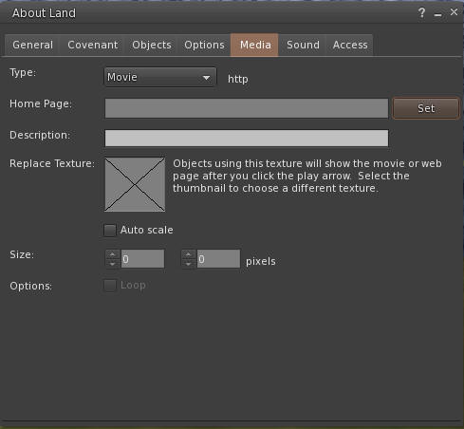  
  
2. Change to the Media Tab:  
  
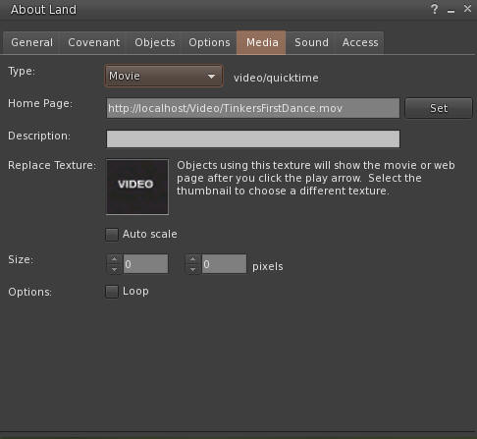  
  
3. Change to the Movie Pulldown  
  
  
  
3. Click the Set button and enter the URL of the desired video.  You can click the link to the sample, and then copy and paste the path.  
or just use http://localhost:80/Video/Tinkers First Dance.mp4  
  
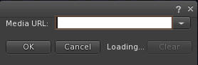  
  
4. You need a unique texture not used before. This PNG file can be used. Right click and save it, and then upload it to your viewer.  
  
  
  
  
Drag and drop the Audio.png file into the X window so it appears like this.  You need to use the web URL for your grid, typically [http://something.outworldz.net:80/](http://something.outworldz.net/Audio)Video/TinkersFirstDance.mov, where 'something' is your chosen URL. You can get this link in the Help menu in the first menu selection. Then change the port to whatever port you use for Apache, in Settings->Apache.  
  
  
  
Make a prim or find a hidden face on a prim. Click "Select Face". Then choose one face only!  Drag and drop the image onto one face only.  
  
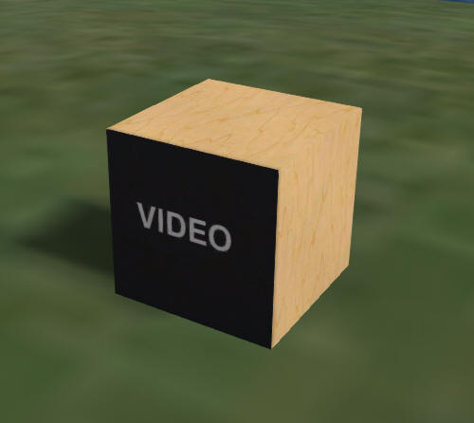  
  
Now click the movie camera at the top right of your viewer:  
  
  
  
  
